Supporting Documents
7.1.3 - Facilities in the Institution for the management of the following types of degradable and non-degradable waste
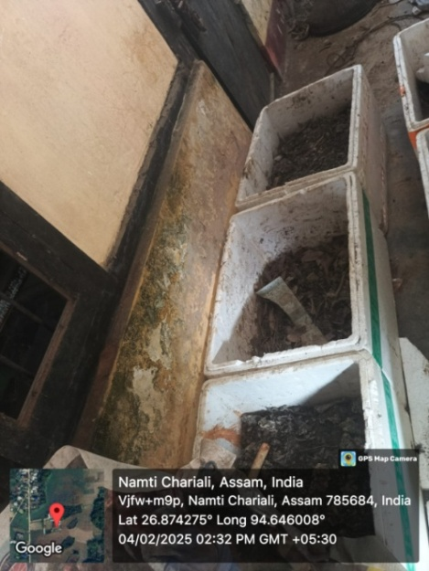
Solid Waste Management
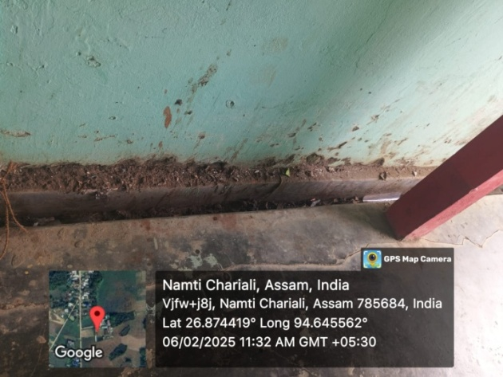
Water Channel
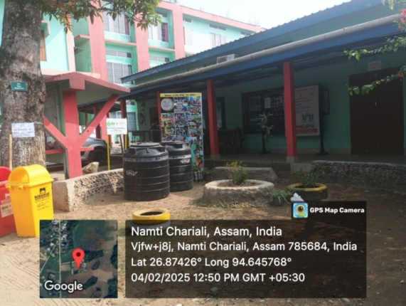

Eco Park Using Waste Materials
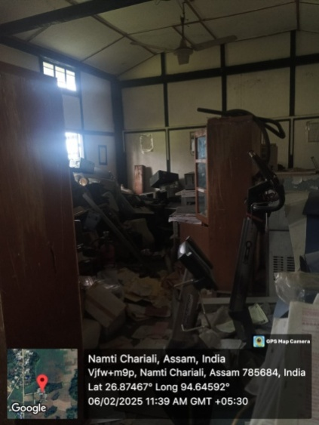

E-Waste Management

