4.3.1: Institution frequently updates its IT facilities and provides sufficient bandwidth for internet connection
- Class-room related IT facility
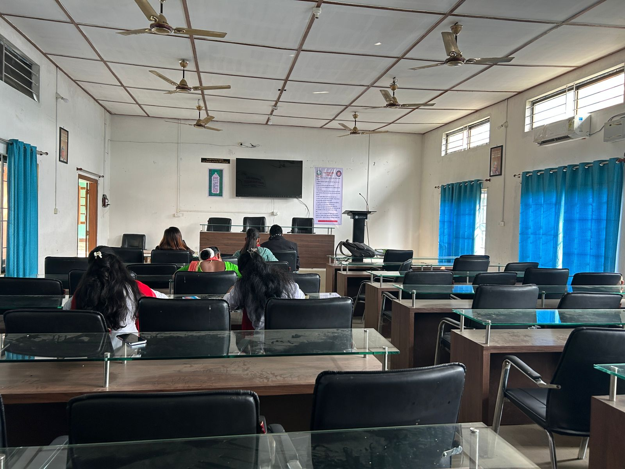
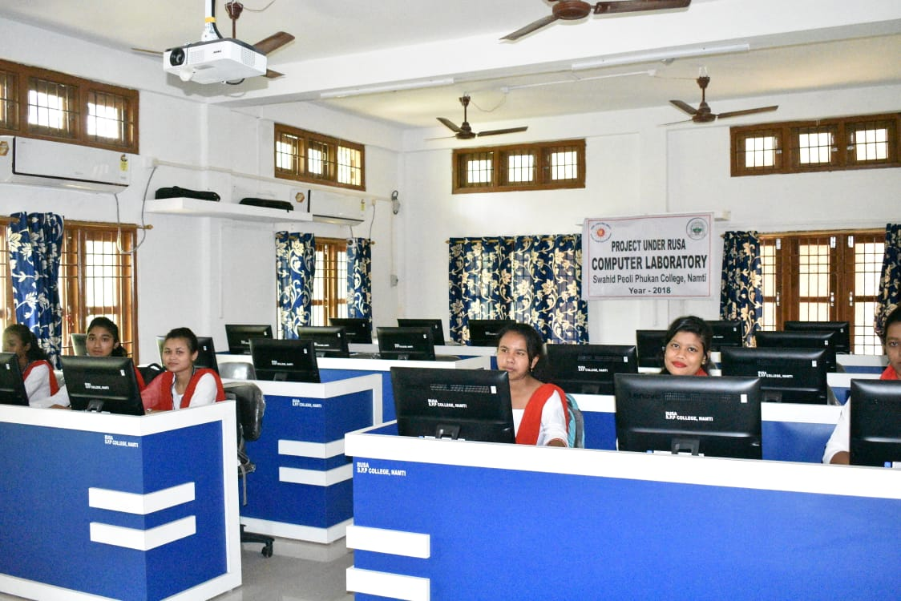
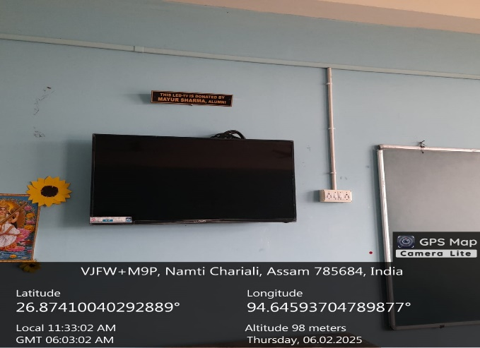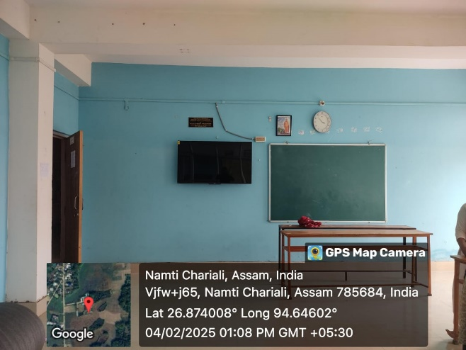
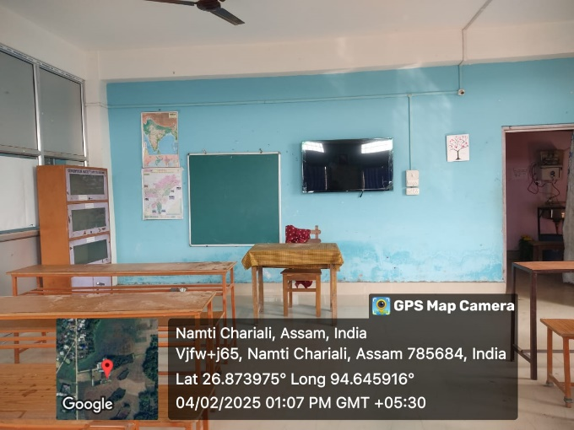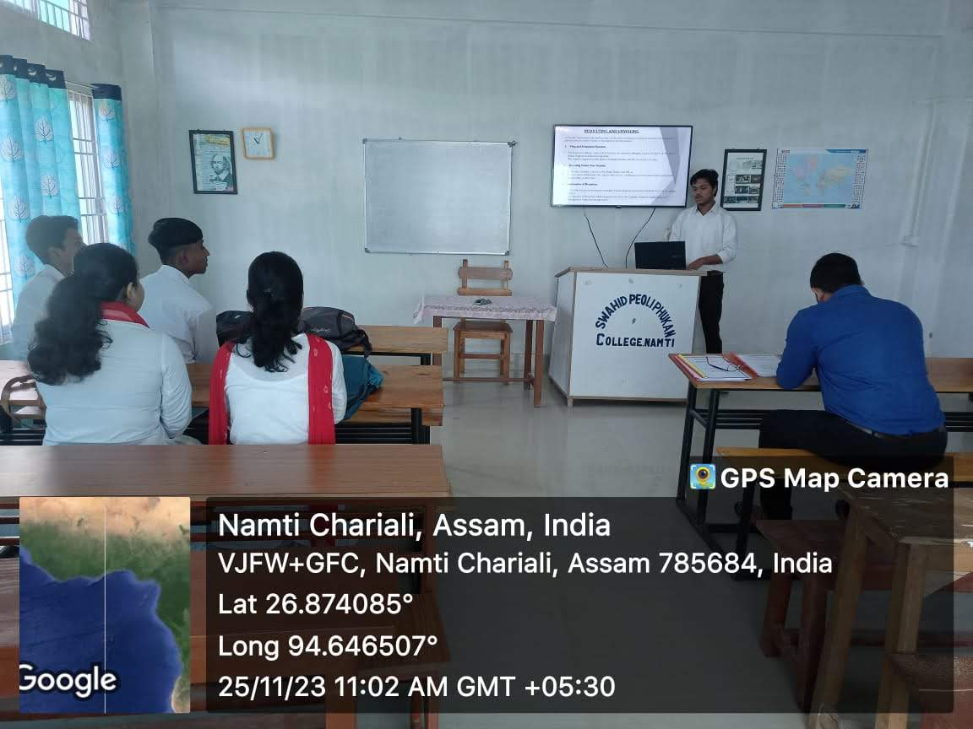
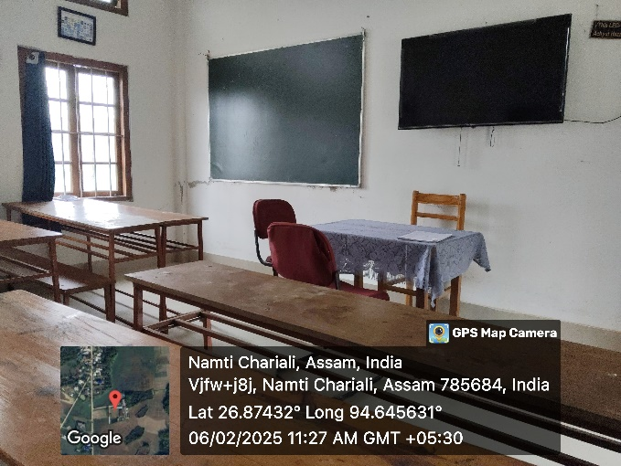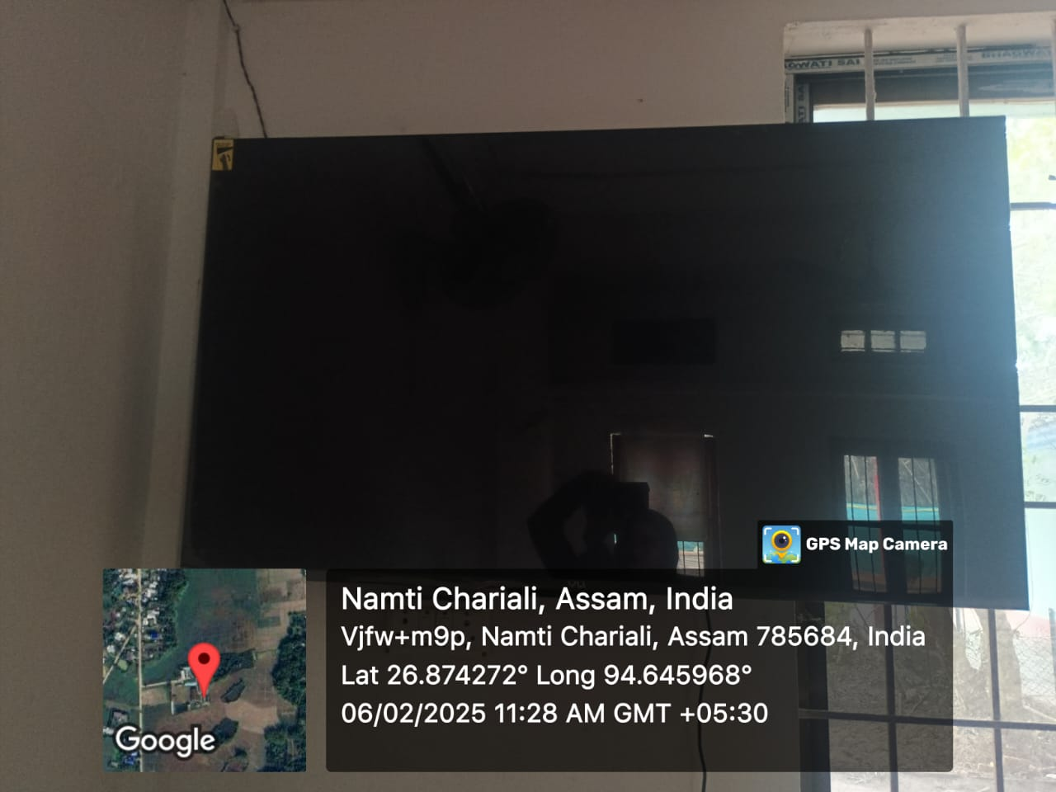
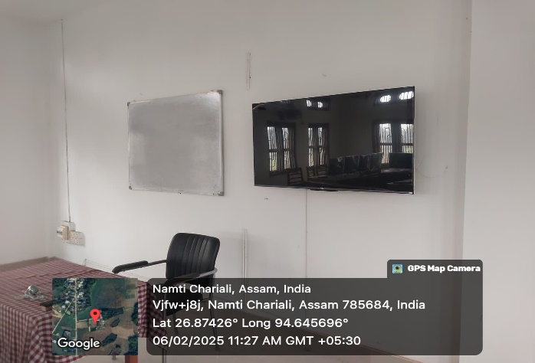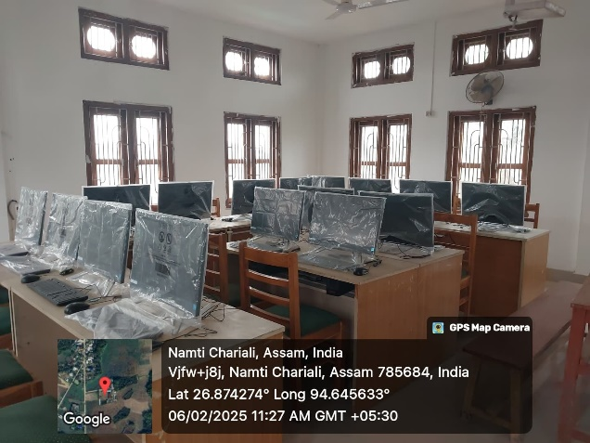

- SPP College library is already automated with Koha Integrated library management system
With the emerging ICT environment the SPP College is also aiming to achieve complete automation of the regular activities of the campus including admission, administrative and academic processes to make it time and user friendly, smart, convenient and transparent. The SPP College library is already automated with Koha Integrated library management system in the cloud environment which facilitate-
Computer-based Circulation, OPAC, Web-OPAC, Digital Repository, Digital Gate Entry Register, Ask the Librarian Service, Service through Social Media.
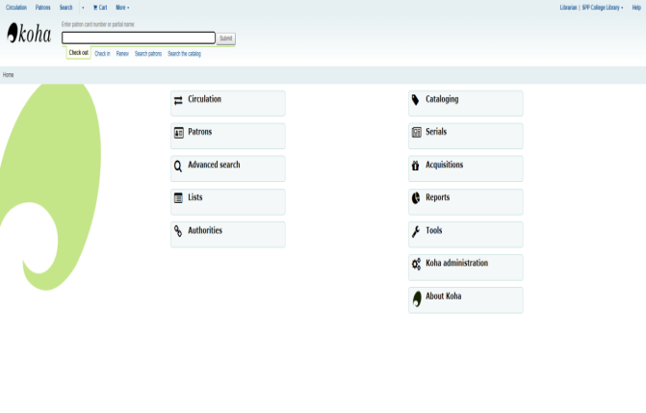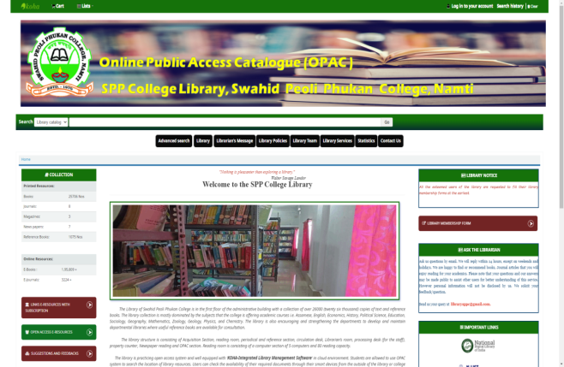

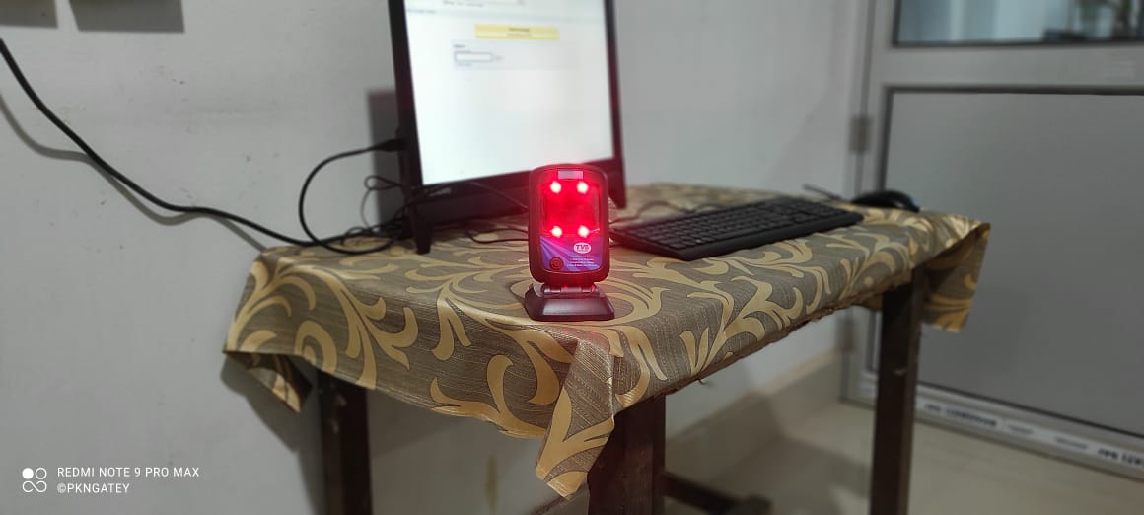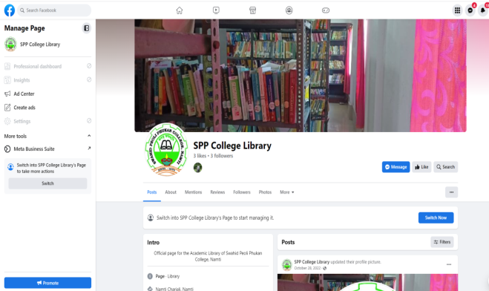

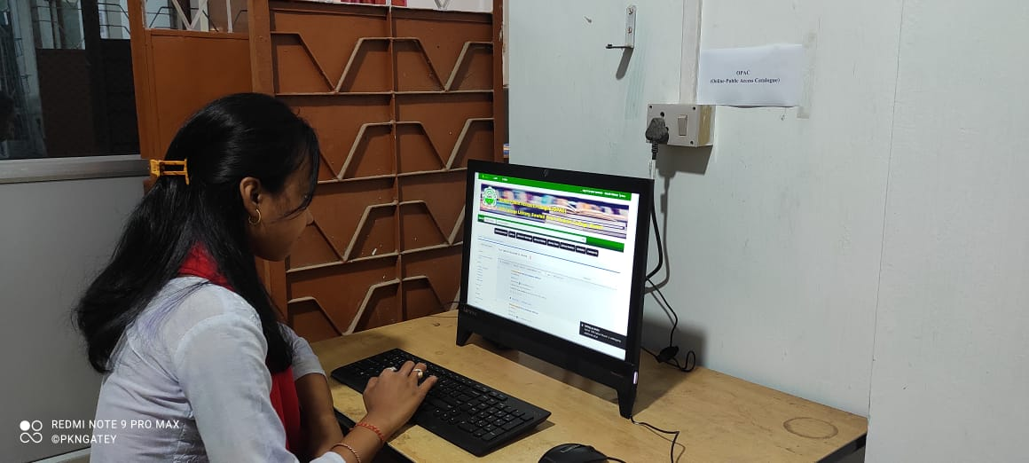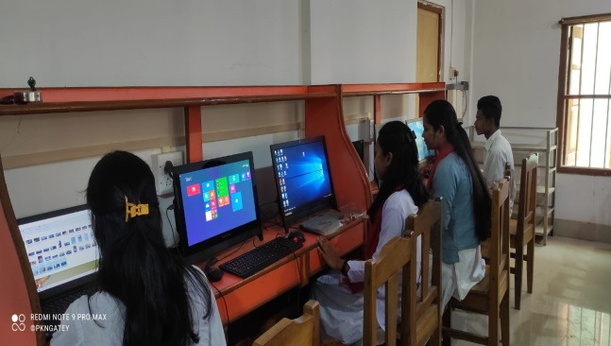

- ICT infrastructure and features are also utilizes in the General, academic and financial administration
ICT infrastructure and features are also utilizes in the General, academic and financial administration of the college for the services like online salary, official communication, financial transaction, e-tendering, PFMS, fully online admission process, registration, form fill-up, admit card issue, other teaching learning practices etc. The departments also make use of Google Classrooms, Youtube, Zoom, Webex etc. for teaching learning practices
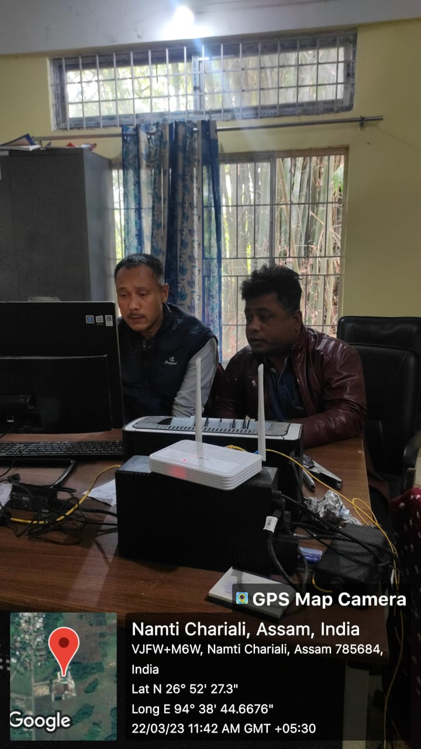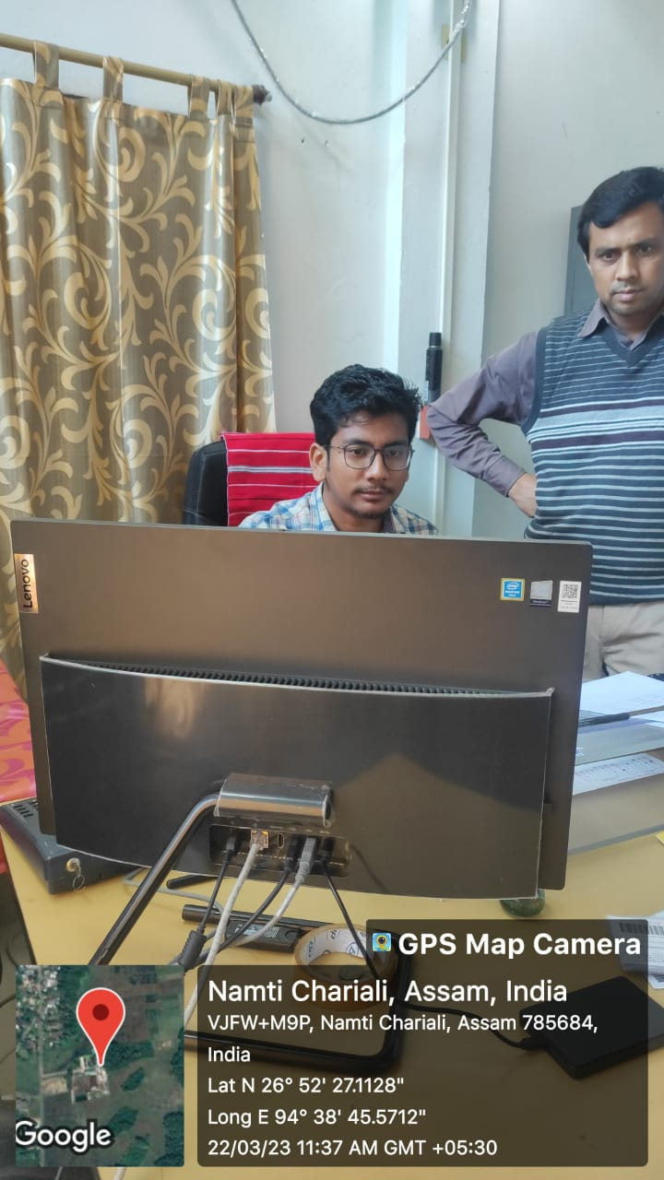
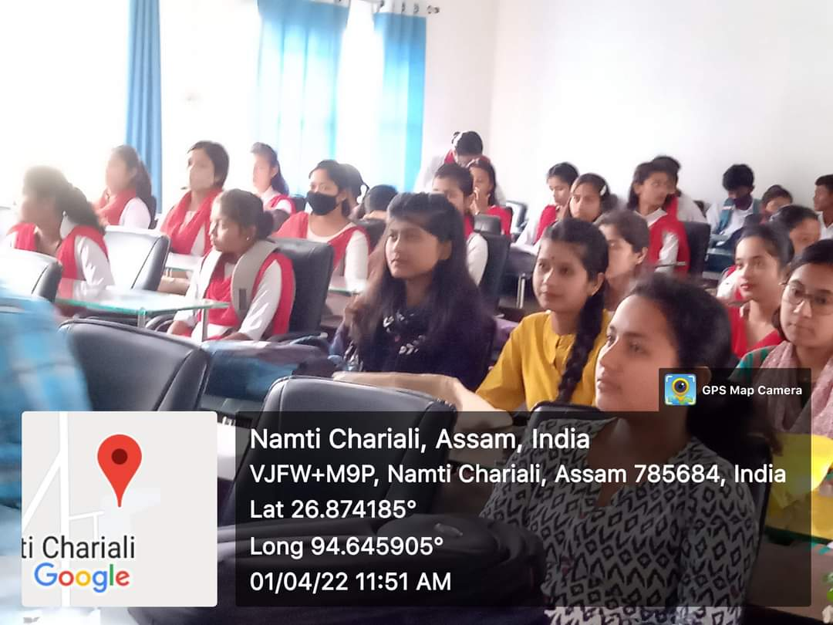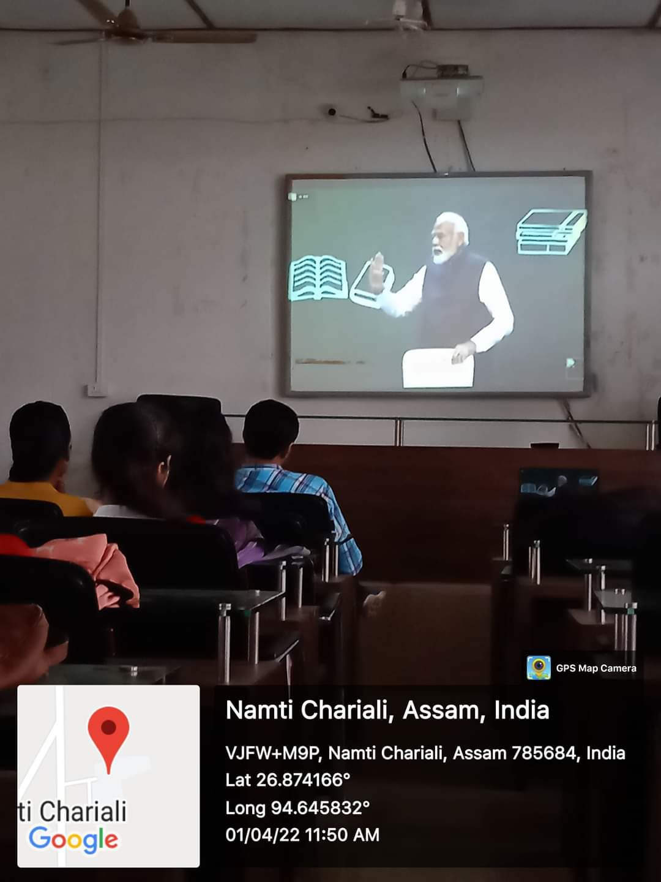

- Biometric attendance and antiviruses for computers
The attendances of the employees are collected through biometric scanner from 2018 onwards. The network connected computers are protected by antiviruses. Moreover, the college hires computer technicians and service providers for any disorder or damage on basis of the need.

